**Mongo Db assignment**

1. Download MongoDB Community Server
   * Visit [MongoDB Official Download Page](https://www.mongodb.com/try/download/community).
   * Select the appropriate version (Windows MSI package).
   * Download and install the .msi file.
2. Install MongoDB
   * Open the downloaded .msi file and follow the installation wizard.
   * Choose Complete Installation.
   * Check the option "Run MongoDB as a Windows Service" (optional).
3. Verify Installation
   * Open Command Prompt and run:

mongod –version

2.Create a directory :

**mkdir C:\data\db**

**3)set up env path**

Open System Properties → Go to Advanced → Click Environment Variables.

Under System Variables, select Path → Click Edit.

Add the MongoDB bin directory (e.g., C:\Program Files\MongoDB\Server\6.0\bin).

Click OK and restart your terminal.

4.Startup MongoDB database

**mongod --dbpath <your_db_directory>**

5. Connect to MongoDB database through the MongoDB shell command line interface

**mongo**

6. View list of available databases

**show dbs**

7. Create a new database named CDAC and connect to it

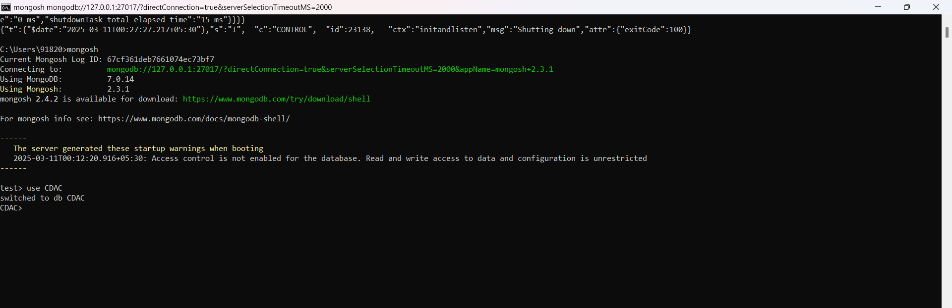

8. View list of available collections in CDAC database

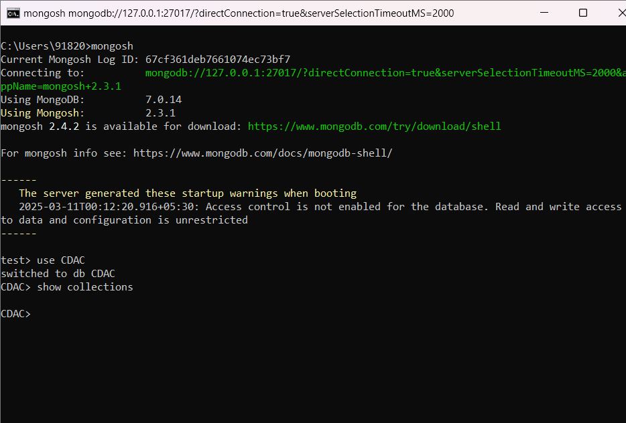

9. Create a new collection by the name of LIBRARY

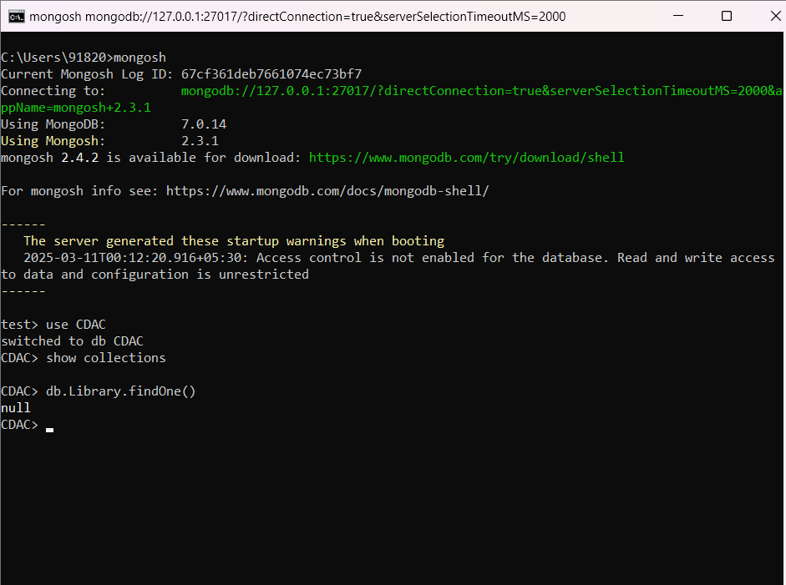

10. Insert the following document in the LIBRARY collection:-

title:'MongoDB programming', author:'Sameer', likes:100

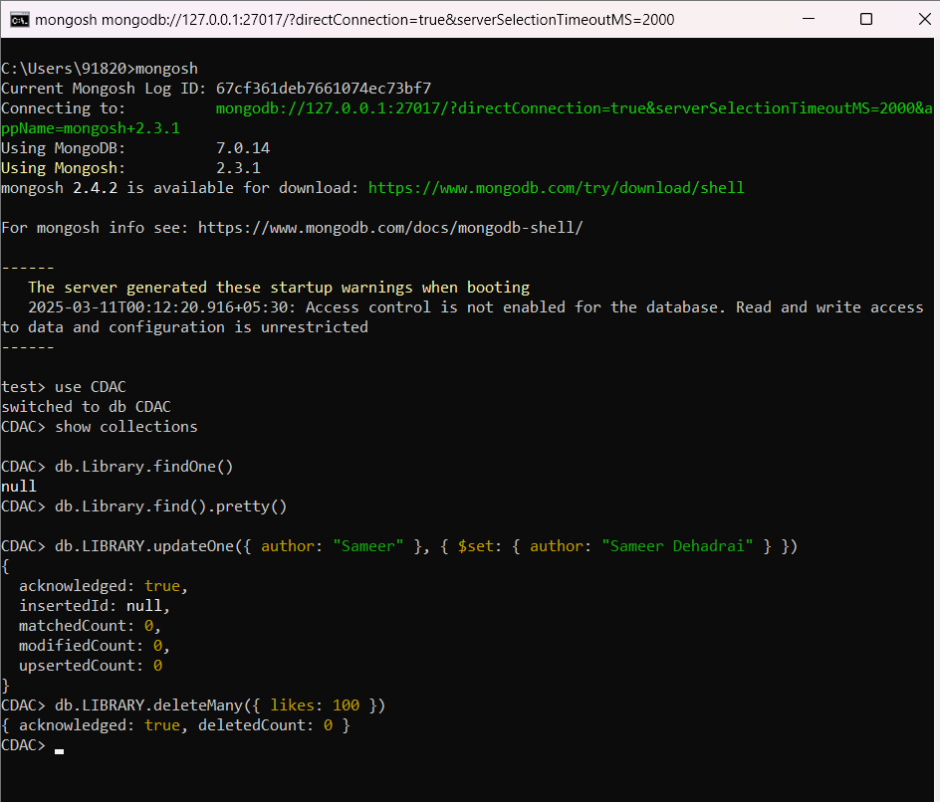

11. View the recently inserted document and note the _id field

12. Insert another document in the LIBRARY collection as follows:-

title:'MySQL programming', authors:['Jack','Jill'], likes:200

**. Insert another document in the LIBRARY collection as follows:-**

**title:'MySQL programming', authors:['Jack','Jill'], likes:200**

13. View the inserted documents

14. View only the first inserted document

**db.LIBRARY.findOne()**

15. View the documents using the pretty() method

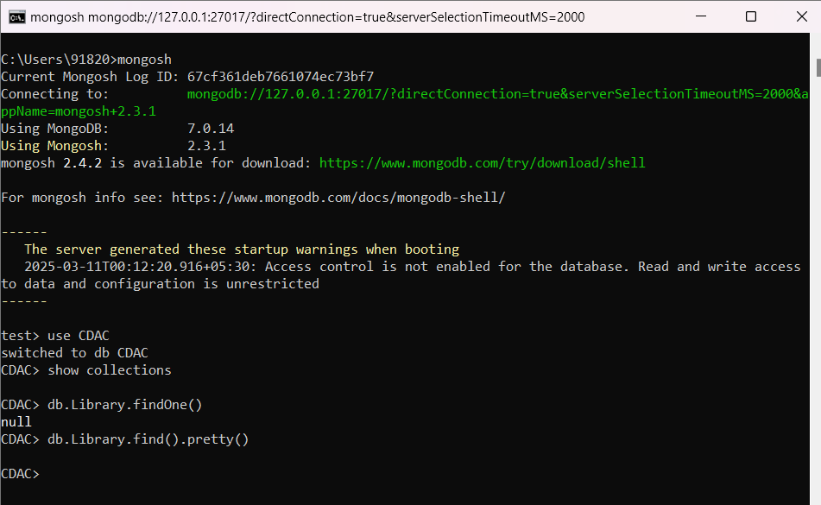

16. Update the document where author name = Sameer and change it to Sameer Dehadrai

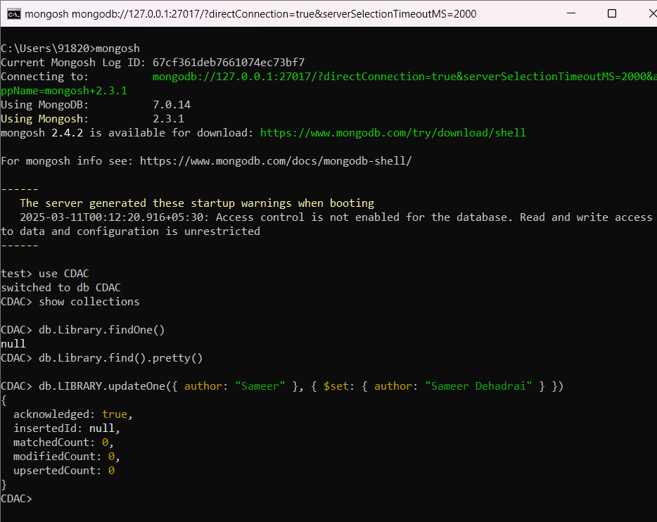

17. Delete all documents that have 100 likes

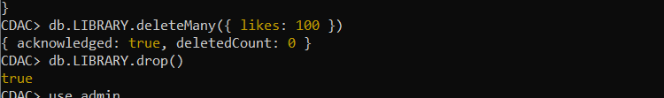

18. Drop the LIBRARY collection

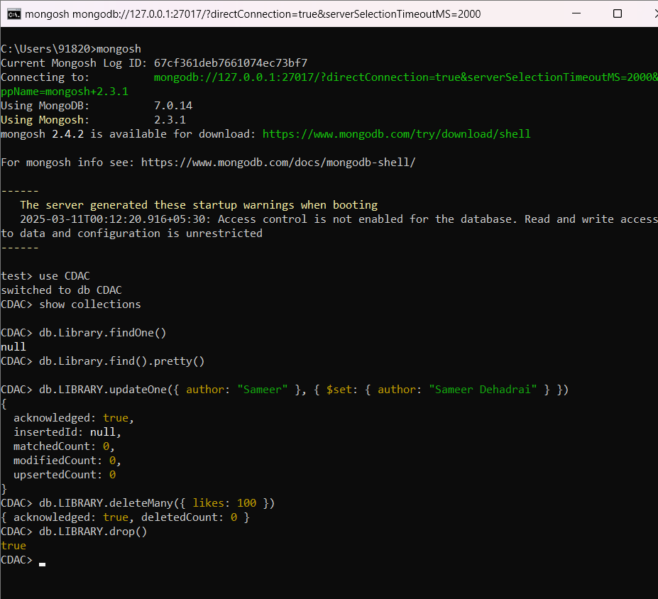

19. Drop the CDAC database

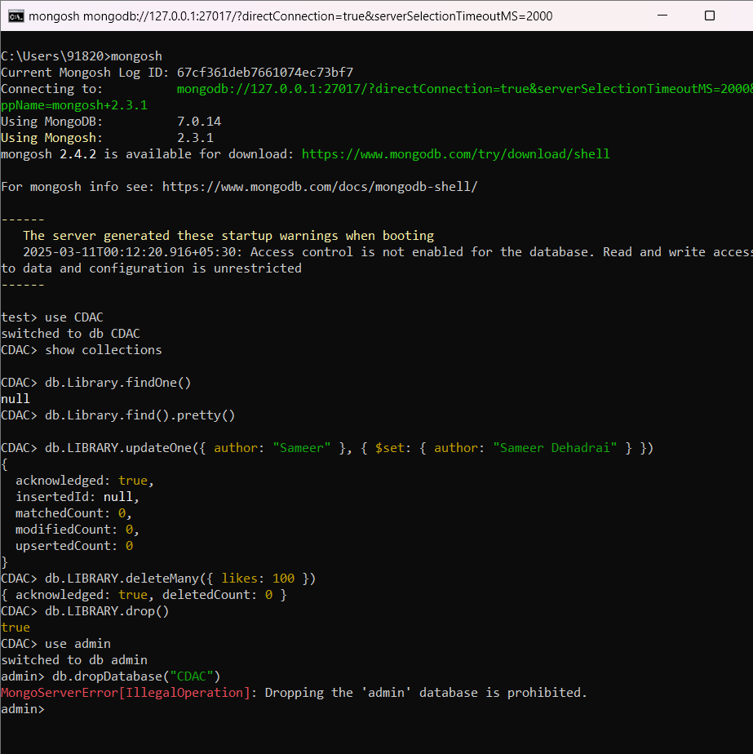

20. Exit from MongoDB shell

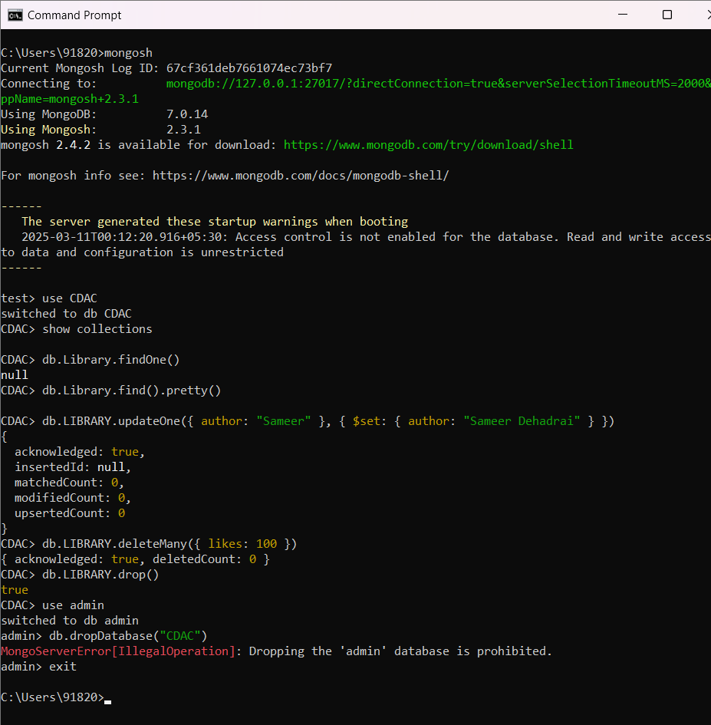

21. Stop MongoDB server

**mongod --shutdown**